Study Room Data - Library

Ryan Iacovone

12/10/2022

**Problem statement:**

The library would like to know how patrons on the top floor are utilizing the four currently available study rooms. The goal is to investigate if the library would benefit from additional study room spaces or if the four currently in use are enough to meet the patron demands. Additionally, if the data illustrates an excess demand for study rooms, it’s important to understand what types of patrons are using the study rooms so that staff can appropriately and informatively make plans for additional study spaces, if so desired. To understand the types of patrons and how they use the study room data will be collected regarding the size of groups commonly requesting study rooms as well as the time-of-day study rooms are requested the most.

**Data Set Description:**

In order to investigate the demands for study rooms, library staff tracked study room usage for a nonconcurrent two-week period in November 2022. A tracking sheet was placed at the front desk for librarians to fill out each time a patron came to the desk requesting a study room. The tracking sheet captured four unique variables: date, time of day, size of group, and finally whether a room was available. The data from tracking sheets was then transferred to an excel file where it was uploaded to the program R to perform statistical analyses.

Table 1.1 General Summary Statistics:

|  |  |  |  |  |  |  |  |  |  |
| --- | --- | --- | --- | --- | --- | --- | --- | --- | --- |
| Yes | No | Overall Success Rate | Min | Q1 | Median | Mean Group Size | Q3 | Max | Mean Count |
| 157 | 56 | 73.70% | 1 | 1 | 1 | 1.22 | 1 | 4 | 11.8 |

Variable definitions:

1. **Yes** = Total number of times patron came to the desk and was able to receive a study room.
2. **No** = Total number of times patron came to the desk and was not able to receive a study room.
3. **Overall Success Rate** = Variable yes divided by total number of times patrons inquired about a study room (in percent format) to get the success rate of a patron walking into EGR KDL and being able to get a study room.
4. **Min** = Smallest group size seeking a study room
5. **Q1** = The 25th percentile marker. 25% of the groups seeking a study room had a group size of 1.
6. **Median** = 50% of groups requesting a study room have a size of 1.
7. **Mean Group Size** = Average size of a group who inquired about a study room.
8. **Q3** = The 75th percentile marker. 75% of the groups seeking a study room had a group size of 1.
9. **Max** = Largest group size seeking a study room.
10. **Mean Count =** Average number of requests for a study room per day.

Table 1.2 Success Rate of Patrons Getting a Study Room by the Time of Day:

|  |  |  |  |  |
| --- | --- | --- | --- | --- |
| **Time** | **Yes** | **No** | **Total** | **Success rate** |
| Morning | 61 | 11 | 72 | 84.7% |
| Afternoon | 82 | 42 | 124 | 66.1% |
| Evening | 14 | 3 | 17 | 82.4% |
| Total | 157 | 56 | 213 | 73.7% |

Variable definitions:

1. **Morning** = 9:30 A.M. – Noon
2. **Afternoon** = Noon – 5 P.M.
3. **Evening** = 5 P.M. until close

Table 1.3 Success Rate of Getting a Study by Individual Day:

Here we can see some of the potential flaws in our data collection technique. Some days have 5 or fewer instances of a patron requesting a study room while other days have 20 plus requests. Consequently, we see that the average number of requests for a study room per day is 11.70. This discrepancy across study room requests per day is most likely due to staff forgetting to write down study room interactions. A patron could have interrupted a staff member right after they gave someone a study room or simply the front desk was too busy to write down the study room request in the moment. As a result, we should view the average number of requests for a study room per day as having undercounted the number of patrons inquiring about a study room.

|  |  |  |  |  |
| --- | --- | --- | --- | --- |
| **Date** | **Yes** | **No** | **Total** | **Success Rate** |
| 11/07/2022 | 9 | 0 | 9 | 100.0% |
| 11/09/2022 | 11 | 5 | 16 | 68.8% |
| 11/10/2022 | 13 | 8 | 21 | 61.9% |
| 11/11/2022 | 10 | 5 | 15 | 66.7% |
| 11/12/2022 | 7 | 3 | 10 | 70.0% |
| 11/13/2022 | 5 | 0 | 5 | 100.0% |
| 11/14/2022 | 13 | 2 | 15 | 86.7% |
| 11/15/2022 | 5 | 3 | 8 | 62.5% |
| 11/16/2022 | 8 | 1 | 9 | 88.9% |
| 11/17/2022 | 9 | 0 | 9 | 100.0% |
| 11/21/2022 | 13 | 9 | 22 | 59.1% |
| 11/22/2022 | 10 | 2 | 12 | 83.3% |
| 11/23/2022 | 10 | 0 | 10 | 100.0% |
| 11/25/2022 | 3 | 0 | 3 | 100.0% |
| 11/26/2022 | 4 | 7 | 11 | 36.4% |
| 11/28/2022 | 8 | 6 | 14 | 57.1% |
| 11/29/2022 | 9 | 1 | 10 | 90.0% |
| 11/30/2022 | 10 | 4 | 14 | 71.4% |
| Total | 157 | 56 | 213 | 73.7% |

Figure 1.1: Histogram Showing Patron Requests for a Study Room Based on the Size of Their Group

Here we see a visual representation of study room requests by group size that confirms our takeaway from the initial summary statistics sections that patrons in a group of 1 dominate requests for a study room at the library. In fact, group size of 1 represents 85% of all study room requests followed by 11% for size of 2 and 2% for group sizes 3 and 4 respectively.

Figure 1.2: Histogram showing Whether a Patron was able to get a Study Room Based on the Size of Their Group:

As in the initial summary statistics section, we can see that a group size of 1 dominated our requests across the board. However, there is reason to believe that the overwhelming number of patrons with a group size of 1 is an over count. For example, when a group of people would like a study room sometimes a delegate is selected among the group to approach the front desk about study room availability. Many times, this patron would be counted as a group of 1 because there would be no way to know that they were a part of a larger group. Secondly, if 1 person checks in at the desk for a study room but plans to be meeting with someone later on (for tutoring, a meeting ect…) they would also incorrectly be counted as a group of 1. This is because at the time of the interaction there was only a single person present without any way for us to know if someone would be joining them (unless of course the patron informed us of their plans).

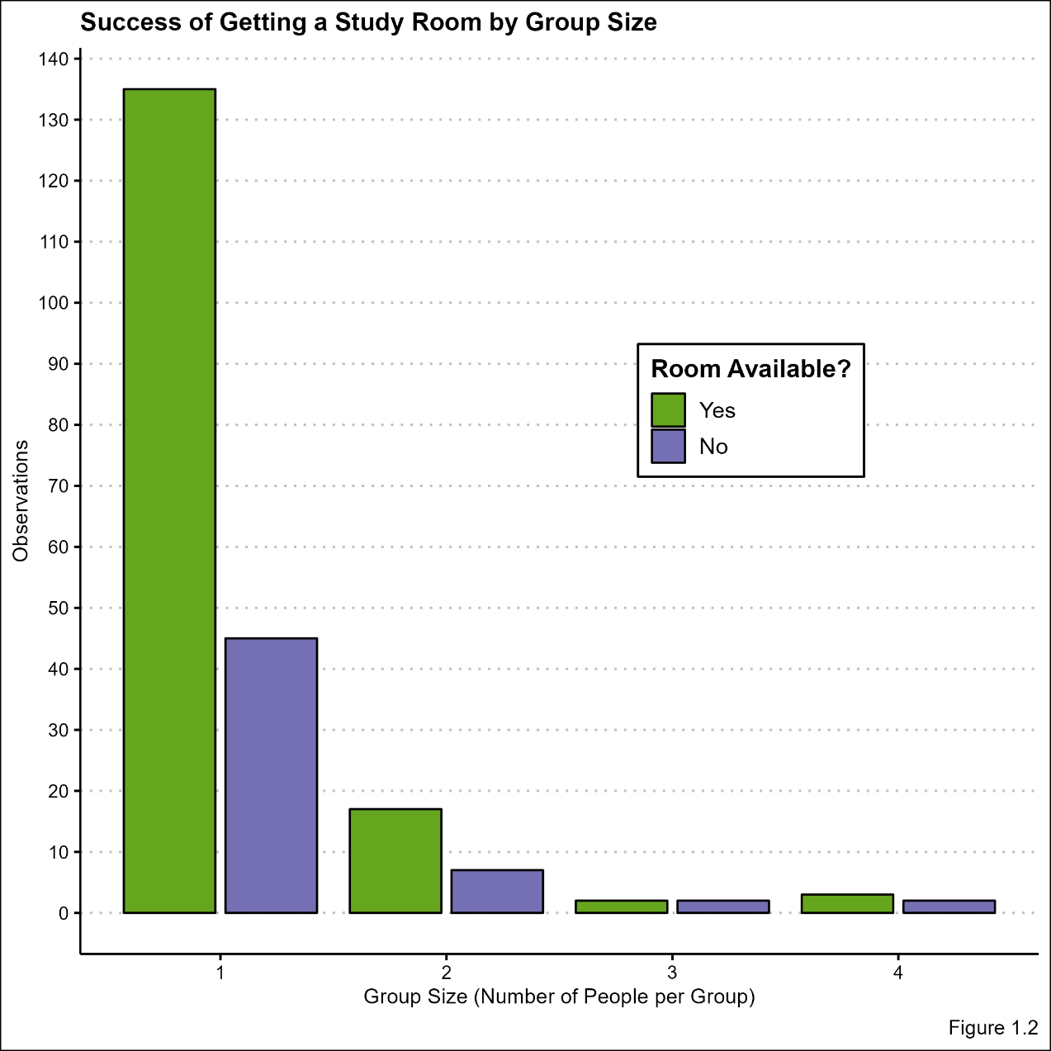

Figure 1.3: Below we see a data visualization (histogram) illustrating study room requests by the time of day:

When looking at the histogram below it’s important to consider that the library’s open hours change depending on the day. For much of the week the library is open until 8pm, however on Friday and the weekend evening hours at the library total one hour giving us much less data for evenings compared to the morning and afternoon time slots.

